CO1 ASSESSMENT TOOL

AI-Based Smart Pharmaceutical Manufacturing Quality Assurance Platform

NAME : MUKESH RAJ L

REG NO:192571036
DEPT: B.TECH CS BS

COURSE CODE: CSA1017

SOFTWARE ENGINEERING

Introduction
The pharmaceutical industry plays a vital role in protecting human health by manufacturing medicines that must meet strict quality and safety standards. Every medicine produced should have the correct composition, dosage, purity, and packaging. Even a small mistake during manufacturing can reduce the effectiveness of the medicine or cause serious health risks to patients.
Traditional pharmaceutical manufacturing mainly depends on manual inspections, periodic quality checks, and human observation. Although these methods have been used for many years, they are time-consuming and prone to human errors. Problems such as contamination, incorrect labeling, damaged packaging, or improper storage conditions may not be detected immediately. As a result, defective medicines may reach the market, leading to financial losses, product recalls, and risks to patient safety.
Modern technologies such as Artificial Intelligence (AI), Internet of Things (IoT), Computer Vision, Cloud Computing, and Machine Learning have made it possible to automate quality assurance. These technologies continuously monitor manufacturing processes, detect defects in real time, predict quality issues before they occur, and ensure compliance with pharmaceutical regulations.
The proposed AI-Based Smart Pharmaceutical Manufacturing Quality Assurance Platform aims to improve manufacturing quality by automating inspection, monitoring production parameters, predicting defects, generating compliance reports, and providing real-time dashboards for manufacturers and regulatory authorities. This intelligent platform will help pharmaceutical companies produce safer medicines, reduce wastage, improve efficiency, and ensure regulatory compliance.

1. Understand the Problem Statement

1.1 Problem Explanation

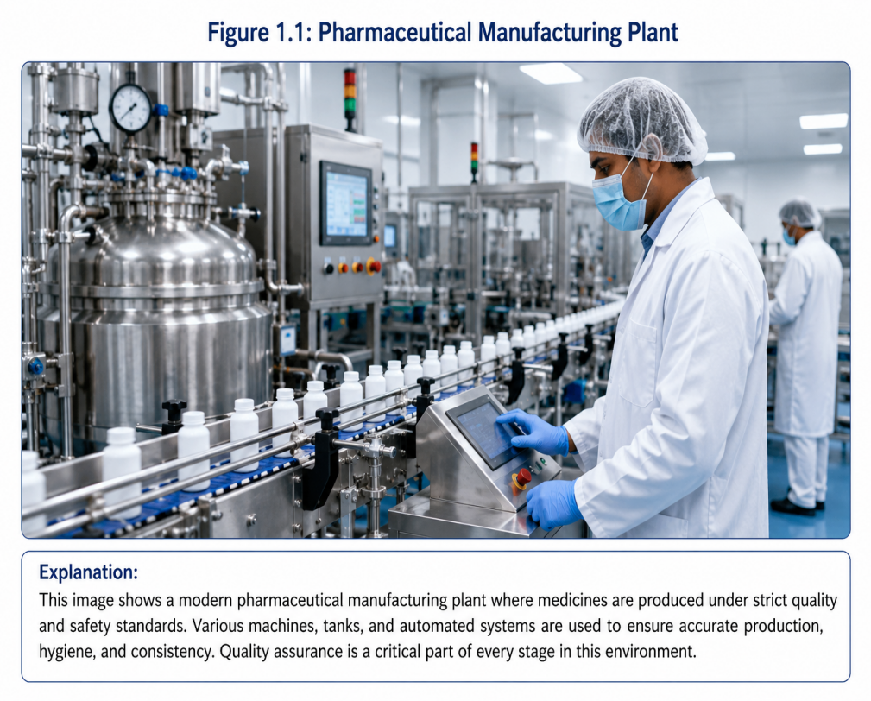

Pharmaceutical companies manufacture millions of medicines every day. Every medicine must satisfy strict quality standards before it reaches patients. However, maintaining consistent quality throughout the manufacturing process is a major challenge.
Most pharmaceutical industries still depend on manual inspections and periodic quality testing. These inspections are performed only at certain stages of production, meaning that defects occurring between inspections may remain unnoticed. Human inspectors can also make mistakes due to fatigue, lack of concentration, or workload. Consequently, defective medicines may be produced without immediate detection.
Several quality issues can occur during pharmaceutical manufacturing, such as:
- Incorrect dosage of ingredients
- Contamination during production
- Defective tablets or capsules
- Improper packaging
- Wrong labeling
- Temperature and humidity variations
- Machine failures
- Batch inconsistencies
When these problems are discovered late, companies may need to recall entire batches of medicines. Product recalls not only result in huge financial losses but also damage the company's reputation and reduce customer trust. More importantly, defective medicines can seriously affect patient health.
The proposed AI-based platform continuously monitors manufacturing operations using IoT sensors, cameras, and AI algorithms. It detects abnormalities immediately, predicts possible failures, maintains digital records of every production batch, and automatically generates regulatory compliance reports. This enables pharmaceutical companies to produce safer medicines while improving operational efficiency.

1.2 Objectives of the Proposed System

Objective 1: Monitor Manufacturing Processes in Real Time
The system continuously collects data from production machines, sensors, and cameras. This allows manufacturers to observe the entire production process without interruption.
Benefit: Early identification of production issues.

Objective 2: Detect Product Defects Using Artificial Intelligence
Computer Vision and AI algorithms inspect tablets, capsules, bottles, labels, and packaging automatically.
Benefit: Defective products are identified immediately before packaging.

Objective 3: Predict Quality Deviations
Machine Learning analyzes historical production data to predict possible quality failures before they happen.
Benefit: Prevents manufacturing errors instead of correcting them later.

Objective 4: Ensure Regulatory Compliance
The system automatically prepares reports according to pharmaceutical regulations such as GMP and FDA standards.
Benefit: Reduces paperwork and improves audit readiness.

Objective 5: Improve Batch Traceability
Every production batch is assigned a digital identity. Manufacturers can trace every medicine from raw materials to delivery.
Benefit: Faster investigation during product recalls.

Objective 6: Reduce Product Wastage
Continuous monitoring identifies production errors early, preventing large quantities of defective medicines.
Benefit: Saves raw materials and reduces manufacturing costs.

Objective 7: Improve Manufacturing Efficiency
Automation minimizes manual inspections and speeds up production.
Benefit: Higher productivity with fewer errors.

Objective 8: Enhance Patient Safety
Only medicines that satisfy quality standards reach the market.
Benefit: Protects patients and increases public confidence.

1.3 Scope of the Proposed System
The scope of this project covers all major activities involved in pharmaceutical quality assurance.

The system includes:
- Raw material inspection
- Manufacturing process monitoring
- AI-based defect detection
- Packaging quality inspection
- Batch traceability
- Temperature and humidity monitoring
- Machine health monitoring
- Quality analytics dashboard
- Compliance report generation
- Administrator dashboard
- Production manager dashboard
- Regulatory authority reports

The system does not include:
- Drug research and development
- Clinical trial management
- Medicine distribution
- Hospital pharmacy management
- Patient medical records
Scope Diagram
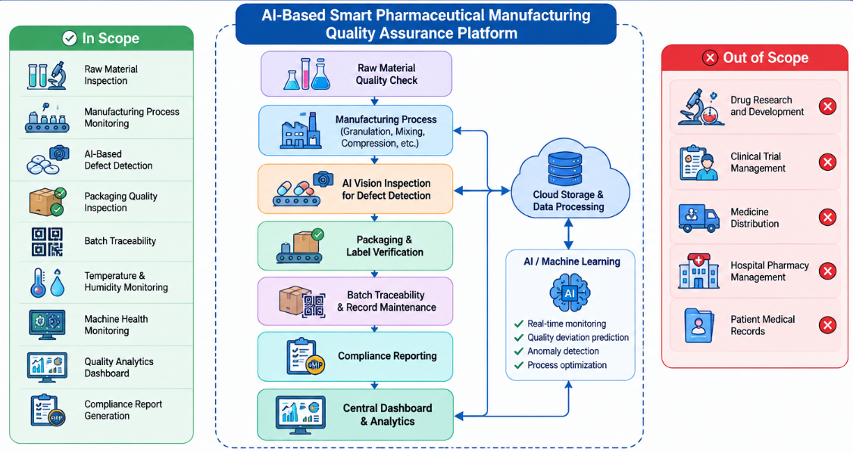

2. Stakeholder Analysis
A stakeholder is any individual, group, or organization that directly or indirectly interacts with the proposed pharmaceutical quality assurance system. Every stakeholder has specific responsibilities that help maintain medicine quality, improve production efficiency, and ensure patient safety.

2.1 Key Stakeholders

Stakeholder | Roles and Responsibilities | Challenges Faced
Pharmaceutical Company Management | Makes strategic decisions, approves budgets, monitors production performance, ensures company growth. | High production cost, maintaining quality standards, regulatory compliance, product recalls.
Quality Assurance (QA) Team | Inspects medicines, verifies product quality, performs quality testing, approves batches before release. | Manual inspection errors, large workload, delayed defect identification.
Production Manager | Supervises manufacturing process, machine operation, workforce management, production scheduling. | Machine downtime, production delays, maintaining consistent quality.
Machine Operators | Operate manufacturing equipment, monitor production lines, report equipment problems. | Complex machines, human mistakes, repetitive work, equipment failures.
Laboratory Technicians | Conduct chemical and microbiological tests on medicines and raw materials. | Time-consuming testing procedures and documentation.
Warehouse Manager | Stores raw materials and finished medicines, maintains inventory, manages environmental conditions. | Inventory mismatch, improper storage, temperature fluctuations.
Regulatory Authorities (FDA, GMP, WHO) | Monitor pharmaceutical standards, conduct audits, approve medicines, verify compliance reports. | Large amount of documentation, delayed reporting, compliance verification.
Patients | Consume medicines manufactured by the company. | Unsafe medicines due to manufacturing defects.
Healthcare Providers (Hospitals & Pharmacies) | Purchase and distribute medicines to patients. | Product recalls, delayed supply, poor medicine quality.
AI System Administrator | Maintains software, user accounts, database security, cloud services, AI models. | Cybersecurity threats, software maintenance, system updates.

2.2 Stakeholder Relationship Diagram
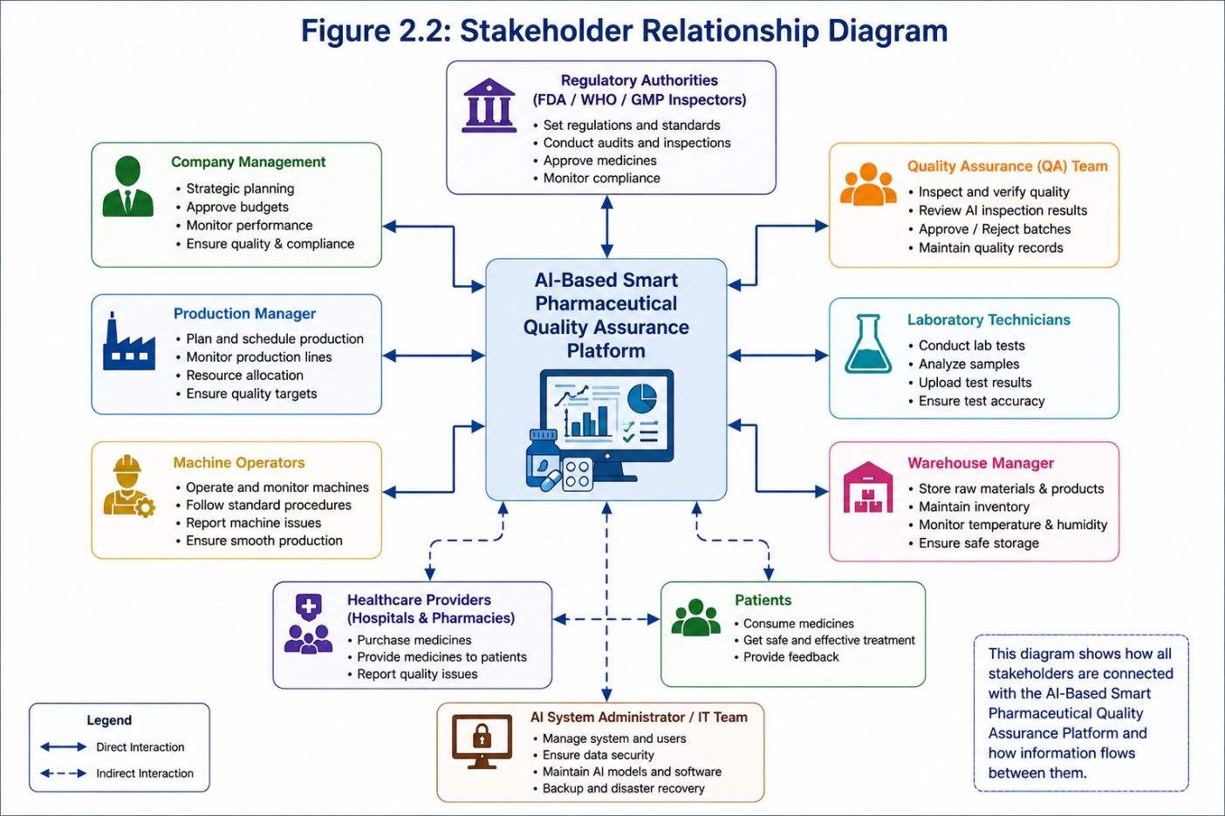

2.3 Roles and Responsibilities (Detailed Explanation)

1. Pharmaceutical Company Management
Management is responsible for planning production, approving investments, ensuring compliance with government regulations, and monitoring overall manufacturing performance. They use dashboards generated by the AI system to make better business decisions.

2. Quality Assurance Team
The QA team ensures every medicine satisfies pharmaceutical quality standards. They verify AI-generated inspection results, approve production batches, investigate defects, and maintain quality documentation.

3. Production Manager
The production manager supervises manufacturing activities, schedules production, allocates resources, and ensures production targets are achieved without compromising quality.

4. Machine Operators
Machine operators control pharmaceutical equipment such as mixers, tablet presses, capsule filling machines, and packaging machines. They immediately report abnormal machine behavior detected by the AI system.

5. Laboratory Technicians
Laboratory staff test medicine samples for purity, strength, contamination, and chemical composition. AI assists by organizing laboratory reports and detecting unusual patterns.

6. Regulatory Authorities
Organizations such as the FDA, WHO, and GMP auditors inspect manufacturing records to ensure medicines satisfy legal safety standards. The proposed system automatically generates audit reports, reducing manual paperwork.

7. Patients
Patients are the final beneficiaries of the system. Improved quality assurance ensures they receive safe, effective, and reliable medicines.

2.4 Major Challenges Faced by Stakeholders

Challenge 1 – Human Errors
Manual inspection may overlook damaged tablets, incorrect labels, or contamination because people become tired after long working hours.

Challenge 2 – Delayed Defect Detection
Traditional inspections occur only after production stages are completed. Defects discovered late result in large quantities of rejected medicines.

Challenge 3 – Machine Failures
Unexpected equipment breakdowns interrupt production schedules and increase maintenance costs.

Challenge 4 – Regulatory Compliance
Maintaining documentation according to GMP and FDA standards requires significant time and effort.

Challenge 5 – Batch Traceability
When defective medicines are discovered, identifying every affected batch becomes difficult without automated tracking.

Challenge 6 – High Production Cost
Poor quality control increases material wastage, product recalls, and operational expenses.

Challenge 7 – Data Management
Modern pharmaceutical industries generate enormous amounts of production data every day. Managing this information manually is inefficient.

Current System Analysis

3.1 Existing System
The existing pharmaceutical quality assurance process primarily depends on manual inspections, laboratory testing, and periodic quality checks.
The manufacturing process follows these steps:
- Raw materials are inspected manually.
- Medicines are manufactured using automated machines.
- Workers visually inspect tablets, capsules, or bottles.
- Laboratory technicians perform sample testing.
- Quality reports are prepared manually.
- Finished medicines are released after approval.
Although this process has been used successfully for many years, it cannot provide continuous real-time monitoring.
3.2 Existing System Workflow
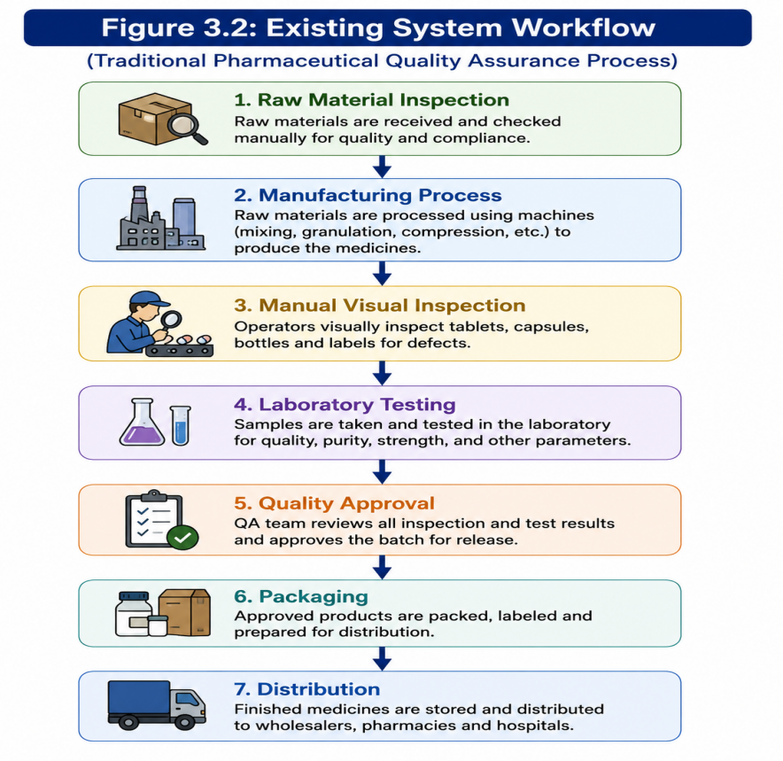

3.3 Strengths of the Existing System

1. Established Process
The current system follows internationally accepted pharmaceutical manufacturing standards.

2. Skilled Workforce
Experienced quality inspectors can identify many manufacturing defects.

3. Laboratory Verification
Laboratory testing ensures medicines satisfy chemical and microbiological requirements.

4. Regulatory Compliance
Companies already maintain documentation according to pharmaceutical regulations.

5. Reliable Equipment
Modern pharmaceutical machinery provides accurate production when properly maintained.
3.4 Limitations of the Existing System
Existing Problem | Explanation
Manual Inspection | Human fatigue causes inspection errors.
Delayed Defect Detection | Problems are identified after production instead of during production.
High Labor Cost | Large inspection teams increase operational expenses.
Slow Documentation | Manual report preparation consumes significant time.
Machine Downtime | Equipment failures are detected only after breakdown.
No Predictive Analysis | Existing systems cannot predict future quality issues.
Limited Traceability | Tracking defective batches is difficult.
Poor Real-Time Monitoring | Continuous production monitoring is unavailable.

3.5 Gap Analysis

Current System | Proposed AI System
Manual inspection | AI Computer Vision inspection
Periodic monitoring | Continuous real-time monitoring
Human decision making | AI-assisted intelligent decision making
Paper-based reports | Automatic digital reports
Reactive maintenance | Predictive maintenance
Manual batch tracking | QR Code & Barcode traceability
Human quality checks | AI defect prediction
Delayed alerts | Instant notifications

4. Proposed Software Solution

4.1 Introduction to the Proposed System

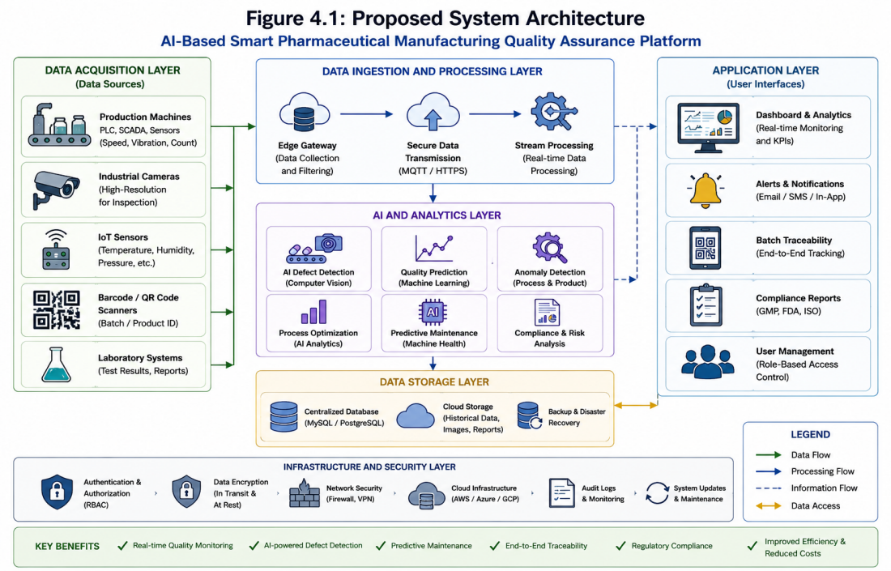

- Explain how the AI-based system works.
- Mention AI, Machine Learning, Computer Vision, IoT, Cloud Computing, QR/Barcode, Database.
- Explain how it solves the limitations of the current system.

4.2 Proposed System Architecture
The AI-Based Smart Pharmaceutical Manufacturing Quality Assurance Platform follows a layered architecture to ensure efficient data collection, intelligent analysis, secure storage, and real-time monitoring. Each layer performs a specific function, making the system modular, scalable, secure, and easy to maintain.

Architecture Overview
The proposed system consists of five major layers:
- Data Acquisition Layer
- Data Processing Layer
- AI & Analytics Layer
- Data Storage Layer
- Application Layer
These layers work together to monitor the pharmaceutical manufacturing process, detect product defects, predict quality issues, and generate compliance reports.

1. Data Acquisition Layer
This is the first layer of the architecture. It collects real-time data from various sources in the pharmaceutical manufacturing plant.
Components:
- Production Machines (PLC/SCADA)
- Industrial Cameras
- IoT Sensors
- QR/Barcode Scanners
- Laboratory Testing Systems
Functions:
- Collect production data
- Capture medicine images
- Monitor temperature and humidity
- Read batch information
- Receive laboratory test results
Explanation:
Whenever medicines are produced, IoT sensors continuously measure environmental conditions such as temperature, humidity, pressure, and vibration. Industrial cameras capture high-resolution images of tablets, capsules, bottles, and labels. Barcode scanners identify each batch uniquely, while laboratory systems upload quality test results. This real-time data is forwarded to the processing layer for further analysis.

2. Data Processing Layer
This layer receives all collected information and prepares it for AI analysis.
Functions:
- Data filtering
- Data cleaning
- Data validation
- Secure data transmission
- Real-time processing
Explanation:
The processing layer removes duplicate or incorrect data before sending it to the AI engine. It also encrypts sensitive production information during transmission to ensure data security and integrity.

3. AI & Analytics Layer
This is the core intelligence layer of the proposed system.
Technologies Used:
- Artificial Intelligence (AI)
- Machine Learning (ML)
- Computer Vision
- Predictive Analytics
Major Functions:
- Detect defective medicines
- Predict quality deviations
- Identify abnormal machine behavior
- Predict equipment failures
- Analyze production performance
- Generate recommendations
Explanation:
Computer Vision algorithms inspect medicines for defects such as cracks, discoloration, broken tablets, incorrect labels, or damaged packaging. Machine Learning models analyze historical production data to predict future quality issues and equipment failures. If any abnormal condition is detected, the system immediately alerts the quality assurance team.

4. Data Storage Layer
All processed information is securely stored in centralized databases and cloud storage.
Stored Data Includes:
- Production records
- Batch information
- Quality reports
- Sensor readings
- Inspection images
- Compliance documents
- Audit logs
Explanation:
The centralized database maintains complete traceability for every medicine batch. Cloud storage ensures backup and disaster recovery while allowing authorized users to access data remotely whenever required.

5. Application Layer
This layer provides interfaces for users to interact with the system.
Modules Include:
- Dashboard & Analytics
- Alert Notification System
- Batch Traceability
- Compliance Reporting
- User Management
Explanation:
Managers, quality inspectors, laboratory staff, and regulatory authorities access the system through secure dashboards. They can monitor production status, receive defect alerts, generate compliance reports, track medicine batches, and analyze manufacturing performance in real time

4.3 Working of the Proposed System
The proposed AI-Based Smart Pharmaceutical Manufacturing Quality Assurance Platform is designed to monitor every stage of pharmaceutical manufacturing automatically. It integrates Artificial Intelligence (AI), Machine Learning (ML), Computer Vision, Internet of Things (IoT), Cloud Computing, and Database Management Systems to improve medicine quality, reduce human errors, and ensure compliance with pharmaceutical regulations.
The system continuously collects production data from different sources, analyzes it using AI algorithms, detects quality issues, predicts equipment failures, and generates real-time alerts and reports. This enables pharmaceutical companies to produce high-quality medicines while reducing manufacturing costs and improving patient safety.
The working of the proposed system is explained in the following steps.

Step 1: Raw Material Inspection
The manufacturing process begins with the inspection of raw materials. Every pharmaceutical ingredient received from suppliers is checked before entering production.
The system records important information such as:
- Supplier details
- Batch number
- Manufacturing date
- Expiry date
- Chemical composition
- Laboratory test results
AI verifies whether the received materials satisfy the required quality standards. Any defective or contaminated material is automatically rejected.
Purpose:
- Prevent poor-quality materials from entering production.
- Ensure only approved raw materials are used.

Step 2: Manufacturing Process Monitoring
Once the raw materials are approved, they move to the production line.
The manufacturing process includes:
- Mixing
- Granulation
- Drying
- Compression
- Capsule filling
- Coating
- Packaging
IoT sensors installed in production machines continuously monitor:
- Temperature
- Humidity
- Pressure
- Machine vibration
- Production speed
- Machine status
All sensor readings are sent to the cloud in real time.
Purpose:
- Monitor production continuously.
- Prevent abnormal manufacturing conditions.

Step 3: Data Collection and Processing
The collected sensor data, machine information, camera images, and laboratory reports are transmitted securely to the central server.
Before analysis, the system performs:
- Data cleaning
- Data validation
- Duplicate removal
- Data formatting
- Secure encryption
This ensures that AI algorithms receive accurate and reliable information.
Purpose:
- Improve data quality.
- Reduce incorrect predictions.

Step 4: AI-Based Defect Detection
High-resolution industrial cameras capture images of tablets, capsules, medicine bottles, labels, and packaging materials.
Computer Vision algorithms analyze every image and compare it with reference standards.
The system can identify defects such as:
- Broken tablets
- Cracked capsules
- Incorrect tablet size
- Color variation
- Missing tablets
- Damaged packaging
- Incorrect labels
- Printing errors
Whenever a defective product is detected, it is automatically removed from the production line.
Purpose:
- Eliminate defective medicines before packaging.
- Reduce manual inspection work.

Step 5: Machine Learning Prediction
Machine Learning analyzes both historical and real-time production data.
It predicts:
- Quality deviations
- Machine failures
- Equipment maintenance requirements
- Future production trends
- Possible contamination risks
Instead of waiting for machine failures, the system predicts them in advance.
Purpose:
- Reduce production downtime.
- Improve manufacturing efficiency.

Step 6: Batch Traceability
Every production batch receives a unique:
- QR Code
- Barcode
- Batch ID
The database stores complete batch information, including:
- Raw material details
- Production date
- Inspection reports
- Machine information
- Quality approval
- Packaging information
If a defect is found later, the entire batch can be identified immediately.
Purpose:
- Improve traceability.
- Simplify product recalls.

Step 7: Compliance Report Generation
The system automatically prepares reports required by pharmaceutical regulatory authorities.
Reports include:
- Production reports
- Quality inspection reports
- Laboratory reports
- Equipment maintenance reports
- Batch history
- Audit reports
The reports follow standards such as:
- GMP (Good Manufacturing Practices)
- FDA Guidelines
- WHO Standards
- ISO Standards
Purpose:
- Reduce paperwork.
- Improve regulatory compliance.

Step 8: Dashboard and Alert System
The final stage of the system is the user dashboard.
Different users such as:
- Company Management
- Quality Assurance Team
- Production Manager
- Laboratory Staff
- Regulatory Authorities
can access real-time information.
The dashboard displays:
- Production status
- Machine health
- Defect percentage
- Sensor readings
- Batch status
- Compliance reports
- AI predictions
If any abnormal condition is detected, the system immediately sends alerts through:
- Email
- SMS
- Mobile Application
- Dashboard Notification
Purpose:
- Enable quick decision-making.
- Prevent quality failures.

4.4 Functional Modules

Module | Description
User Management | Manages users and authentication
Production Monitoring | Tracks manufacturing process
AI Defect Detection | Detects defective medicines
IoT Sensor Monitoring | Monitors temperature, humidity, pressure
Batch Traceability | Tracks every medicine batch
Machine Health Monitoring | Predicts equipment failures
Compliance Reporting | Generates FDA/GMP reports
Dashboard & Analytics | Displays reports and statistics

4.5 Functional Requirements
- User Login
- Production Monitoring
- AI Inspection
- Sensor Monitoring
- QR Code Tracking
- Report Generation
- Dashboard
- Notification System

4.6 Non-Functional Requirements

Requirement | Description
Performance | Real-time monitoring
Security | Role-based login, encryption
Reliability | 24×7 availability
Scalability | Can support multiple factories
Maintainability | Easy updates
Availability | Continuous monitoring
Usability | Easy-to-use interface
Portability | Works on desktop and cloud

4.7 Advantages of the Proposed System
- Faster quality inspection
- Reduced human error
- Automatic defect detection
- Predictive maintenance
- Real-time monitoring
- Better compliance
- Improved patient safety
- Reduced production cost

5. SDLC Methodology Justification

5.1 Agile Methodology
Agile is a flexible SDLC model that develops software in small phases called sprints. It allows continuous testing, feedback, and improvement throughout the project. Agile is suitable for AI-based systems because requirements can change during development.

5.2 Scrum
Scrum is an Agile framework that divides the project into short sprints (2–4 weeks). Each sprint delivers a working part of the software.
Scrum Roles:
- Product Owner – Defines project requirements.
- Scrum Master – Manages the Scrum process.
- Development Team – Develops and tests the software.

5.3 Why Agile?
Agile is chosen because it:
- Supports continuous development.
- Easily adapts to changing requirements.
- Delivers software faster.
- Improves software quality through regular testing.
- Encourages teamwork and customer feedback.

5.4 Sprint Planning
Sprint | Task
Sprint 1 | Requirement Analysis
Sprint 2 | System Design
Sprint 3 | Development
Sprint 4 | Testing
Sprint 5 | Deployment & Review

5.5 Benefits of Agile
- Faster software development.
- Better software quality.
- Easy to handle changes.
- Continuous customer feedback.
- Reduced project risk.
- Improved teamwork.
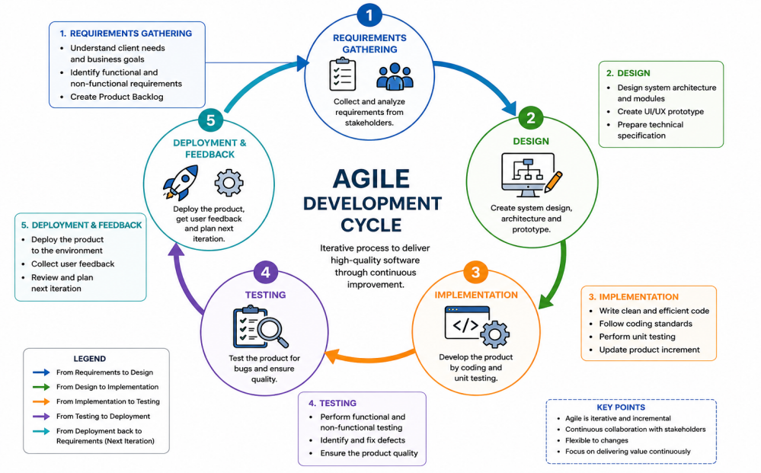

6. Expected Outcomes and Limitations

6.1 Expected Outcomes
The proposed AI-Based Smart Pharmaceutical Manufacturing Quality Assurance Platform is expected to improve the efficiency, accuracy, and reliability of pharmaceutical manufacturing. By integrating AI, IoT, Computer Vision, and Machine Learning, the system helps ensure that only high-quality medicines reach the market.

Expected Outcomes
- Improved Medicine Quality
AI automatically detects defective tablets, capsules, labels, and packaging, ensuring only quality products are released.
- Real-Time Manufacturing Monitoring
IoT sensors continuously monitor temperature, humidity, pressure, and machine performance, reducing production errors.
- Reduced Human Errors
Automated inspection minimizes mistakes caused by manual quality checking.
- Faster Defect Detection
Computer Vision identifies defects instantly, reducing the number of defective medicines produced.
- Enhanced Regulatory Compliance
The system automatically generates FDA, GMP, and quality assurance reports, making audits easier.
- Better Batch Traceability
Every medicine batch can be tracked using QR codes or barcodes, enabling quick product recalls when necessary.
- Reduced Production Cost
Early defect detection and predictive maintenance decrease material wastage and equipment downtie.
- Improved Patient Safety
High-quality medicines with fewer manufacturing defects increase patient safety and public trust.

6.2 How the Proposed Solution Addresses the Challenges

Identified Challenge | Proposed Solution
Manual inspection errors | AI-based automatic defect detection
Delayed quality checks | Real-time monitoring using IoT sensors
Machine failures | Machine Learning-based predictive maintenance
Poor batch tracking | QR code and barcode-based traceability
Manual report generation | Automatic compliance reporting
Slow decision-making | Real-time dashboard and instant alerts

6.3 Limitations
Although the proposed system offers many advantages, it also has some limitations.
- High Initial Cost
  - Installing AI cameras, IoT sensors, cloud infrastructure, and software requires significant investment.
- Dependence on Internet Connectivity
  - Cloud-based monitoring requires a stable internet connection for uninterrupted operation.
- Need for Skilled Personnel
  - Employees must be trained to operate and maintain AI-based systems.
- Data Security Risks
  - Sensitive manufacturing data stored in the cloud must be protected against cyberattacks.
- Regular AI Model Updates
  - AI algorithms require continuous training and updates to maintain high accuracy.

6.4 Future Enhancements
The proposed system can be further improved by adding advanced technologies in the future.
- Integrate Blockchain for secure and tamper-proof batch traceability.
- Develop a mobile application for remote monitoring and instant notifications.
- Use Digital Twin Technology to simulate manufacturing processes before production.
- Implement Advanced Predictive Analytics for better quality forecasting.
- Integrate Robotic Automation for fully automated quality inspection.
- Add Voice Assistant Support for hands-free factory monitoring.

Conclusion
The AI-Based Smart Pharmaceutical Manufacturing Quality Assurance Platform provides an intelligent and automated approach to pharmaceutical quality management. By combining Artificial Intelligence, IoT, Computer Vision, and Machine Learning, the system improves medicine quality, reduces human errors, enables real-time monitoring, ensures regulatory compliance, and enhances patient safety. Although the implementation cost is high, the long-term benefits such as improved efficiency, reduced wastage, and better product quality make it a valuable solution for modern pharmaceutical industries.
This section aligns with your faculty's required format by covering expected benefits, how the solution addresses challenges, limitations, and future enhancements.

